

**KCA UNIVERSITY**

**FACULTY OF COMPUTING AND INFORMATION MANAGEMENTS**

**BACHELOR OF SCIENCE SOFTWARE DEVELOPMENT**

**BSD 2201**

**NETWORKING SCIENCE THEORY**

**KAMAU SAMUEL GACHUNGA**

**19/02761**

**CAT 1**

ERDOS-RENYI RANDOM GRAPHS

# Introduction

The Erdős–Rényi model refers to one of two closely related models for generating random graphs or the evolution of a random network.

# Background

The original Erdos-Renyi graph model has two input parameters: the total number of nodes n and the probability of connection p. Basically, we include the edge (i,j) in the graph with probability p and the edges are all independent from each other.

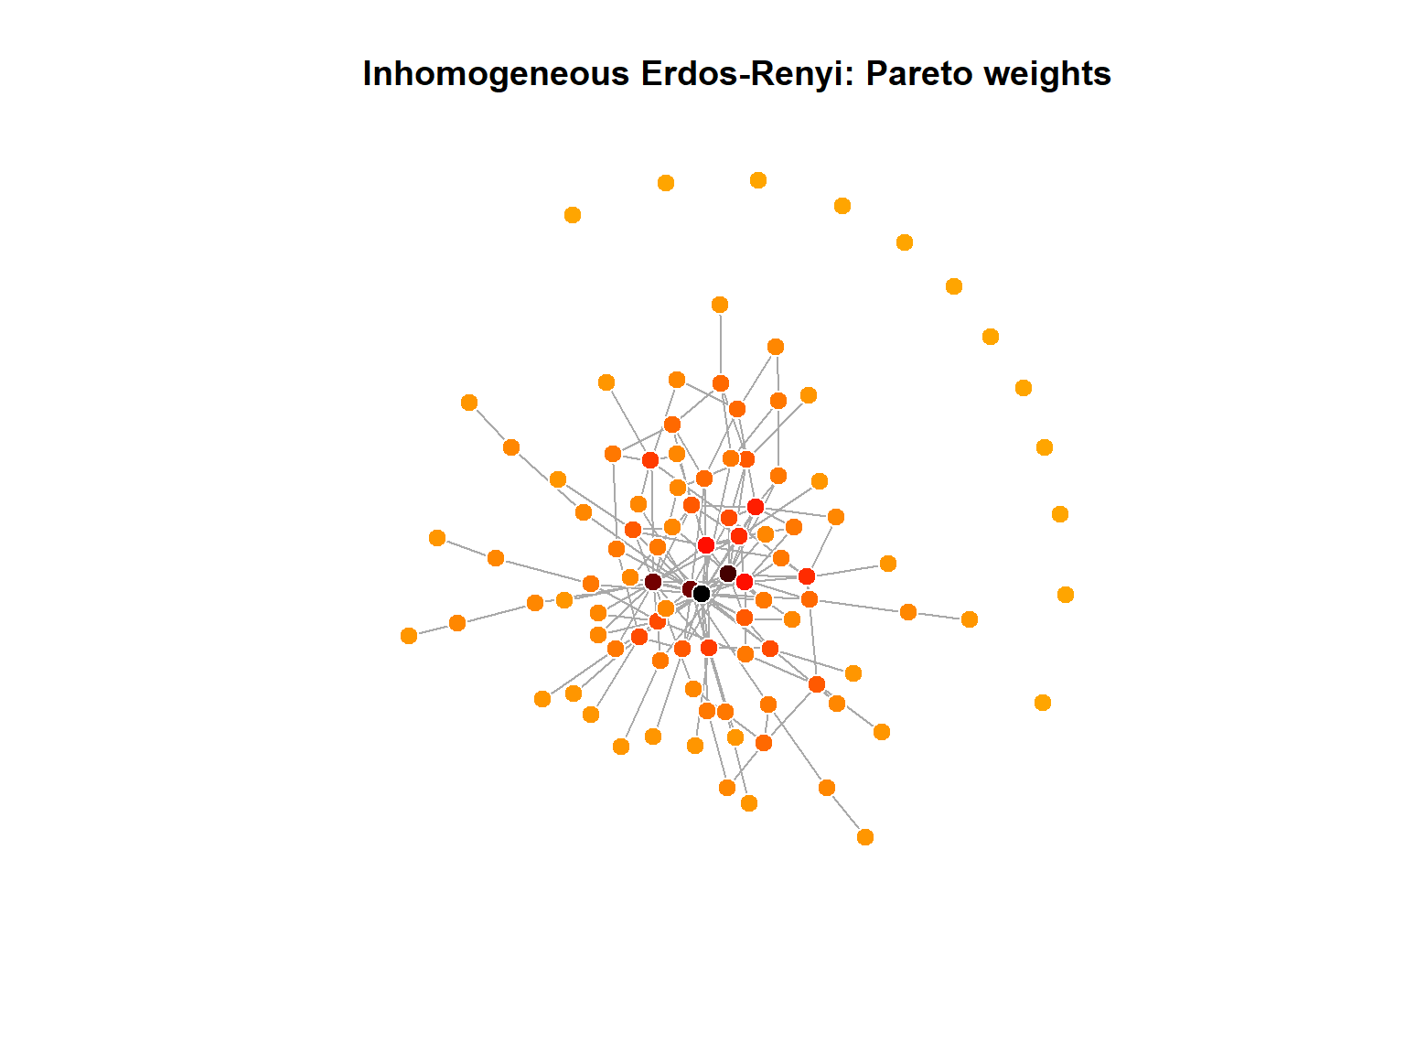

## Variants

There are two closely related variants of the Erdős–Rényi random graph model.

1. G(n, M) model is a graph generated by the binomial model of Erdős and Rényi (p = 0.01)
2. G(n,p) model is a graph is constructed by connecting labelled nodes randomly. Each edge is included in the graph with probability p, independently from every other edge.

Edge-dual graphs of Erdos-Renyi graphs are graphs with nearly the same degree distribution, but with degree correlations and a significantly higher clustering coefficient.

The Erdős–Rényi process is in fact unweighted link percolation on the complete graph.

WATTS-STROGATZ MODEL

# Introduction

The Watts Strogatz model is a random-graph generation model that produces with small world properties, including short path lengths and high clustering.

It was proposed by Duncan J. watss and Steven Strogatz.

# Background

The Watts and Strogatz model was designed as the simplest possible model that addresses the first of the two limitations. It accounts for clustering while retaining the short average path lengths of the ER model. It does so by interpolating between a randomized structure close to ER graphs and a regular ring lattice.

# Properties

The underlying lattice structure of the model produces a locally clustered network, while the randomly rewired links dramatically reduce the average path lengths.

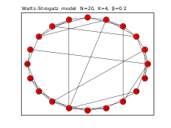

# Limitations

The major limitation of the model is that it produces an unrealistic degree distribution. In contrast, real networks are often scale-free networks inhomogeneous in degree, having hubs and a scale-free degree distribution. Such networks are better described in that respect by the preferential attachment family of models, such as the Barabási–Albert (BA) model.

Key differences Between the two

* The major limitation of the E-R Random Graphs model is that it produces an unrealistic degree distribution. In contrast, real networks are often scale-free networks inhomogeneous in degree, having hubs and a scale-free degree distribution. Such networks are better described in that respect by the preferential attachment family of models, such as the Barabási–Albert (BA) model.
* ER random do not account for the formation of hubs. Formally, the degree distribution of ER graphs converges to a Poisson distribution, rather than a power law observed in many real world, scale free networks.
* Erdős–Rényi graphs have low clustering, unlike many social networks.

# Conclusion

The Watts and Strogatz model was designed as the simplest possible model that addresses the first of the two limitations. It accounts for clustering while retaining the short average path lengths of the ER model. It does so by interpolating between a randomized structure close to ER graphs and a regular ring lattice.

# References

<http://bioinformatics.cs.vt.edu/~murali/teaching/2020-spring-cs4884/lectures/lecture-05-small-world-networks.pdf>

<https://www.dam.brown.edu/MSF/misc/MSF_SimulationsClass3.html>

<https://en.wikipedia.org/wiki/Erd%C5%91s%E2%80%93R%C3%A9nyi_model#:~:text=Exponential%20random%20graph%20models%20%E2%80%93%20Statistical,various%20parameters%20associated%20with%20them>.

<https://en.wikipedia.org/wiki/Watts%E2%80%93Strogatz_model>